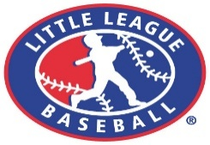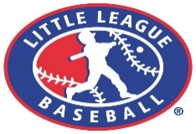
Team Sponsorship / Donation Application
BUSINESS NAME:______________________________________________________________
ADDRESS:___________________________________Website:___________________________________

CONTACT NUMBER:__________________________________EMAIL:____________________________

CONTACT PERSON:_______________________________________________________________

______ I/we agree to sponsor a Team for the 2026 Baseball season. Enclosed is the sponsorship application fee of $400.00 per team which includes a business billboard, website banner and ad on Clifton Little League’s website with a link to the sponsor’s business site.

Name of Team 1________________________________________________________________

Name of Team 2________________________________________________________________

______ I/we agree to advertise our business on a Field Billboard, which will be displayed from Opening Day (or as close to Opening Day as possible), and will remain on the field until fall/winter. Enclosed is the advertising fee of $150.00 per sign which includes a banner or ad on Clifton Little League’s website with a link to the sponsor’s website. Field Billboards will be renewable for each consecutive season for a cost of $75.00.

______ I/we agree to RENEW our existing Field Billboard for 2026 including a banner or ad on Clifton Little League’s website with an online ad. ($75.00)

______ I/we agree to advertise a banner or ad on Clifton Little League website with an online link. ($50.00)

______ I/we agree to advertise our business in the Clifton Little League Opening Day Program with a Business Card or Booster Ad. ($25.00)

______ Any other Donation (support of field supplies and maintenance & Clubhouse maintenance). $_________

Total amount enclosed: $___________________

Sign:_________________________________________ Date:______________

If you have a business card or letter head with your logo, please provide us a copy

Please Note: All applications will be handled in the order they are received.

YOUR SUPPORT AND GENEROSITY IS GREATLY APPRECIATED!!!!!!

